|  |
| --- |
| ZEWAIL CITY: UNIVERSITY OF SCIENCE AND TECHNOLOGY |
| **Principles of Microwaves and Waveguides: Course Project Report** |
| NANENG 430 – Spring 2020 |
|  |
| **Rami Shoula ID: 201600112** |
| **5/4/2020** |

Contents

II. A) 3

A. The Fundamental TM Mode at port 1: 3

B. Global Evaluation settings 4

C. Table calculation 4

D. Neff 4

E. Normalized Electric Field Intensity 5

F. Reflection and Transmission Calculations 5

G. Comments 5

III. B) 6

A. The Fundamental TM Mode at port 1: 6

B. Table calculation 6

C. Neff 6

D. Normalized Electric Field Intensity 7

E. Reflection and Transmission Calculations 7

F. Comments 7

IV. C) 8

A. The Fundamental TM Mode at port 1: 8

B. Table calculation 8

C. Neff 8

D. Normalized Electric Field Intensity 9

E. Reflection and Transmission Calculations 9

F. Comments 9

V. D) 10

A. The Fundamental TM Mode at port 1: 10

B. Table calculation 10

C. Neff 10

D. Normalized Electric Field Intensity 11

E. Reflection and Transmission Calculations 11

F. Comments 11

# A)

## The Fundamental TM Mode at port 1:

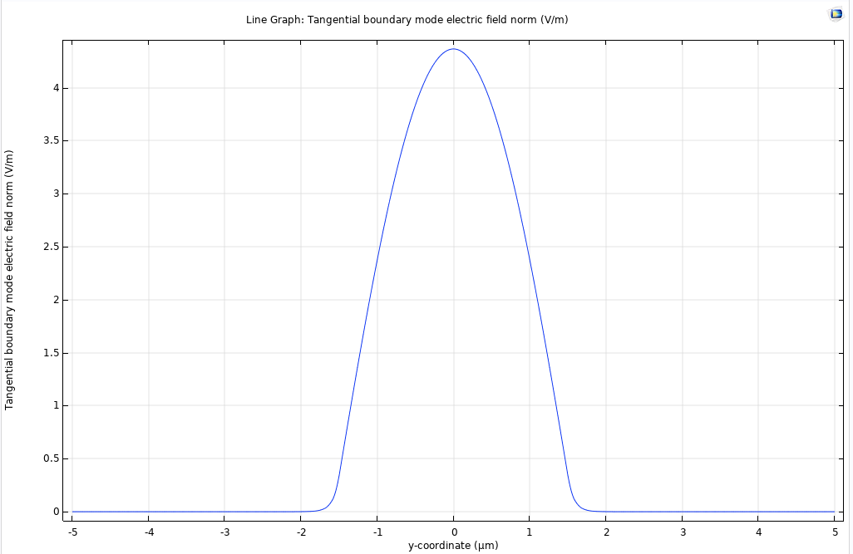

## Global Evaluation settings

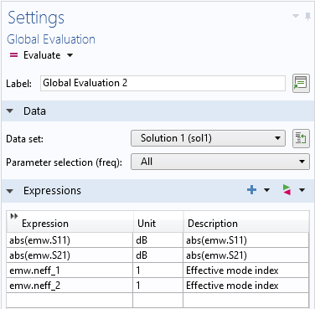

## Table calculation



## Neff

𝑛𝑒ff = 3.4312343239544405

## Normalized Electric Field Intensity

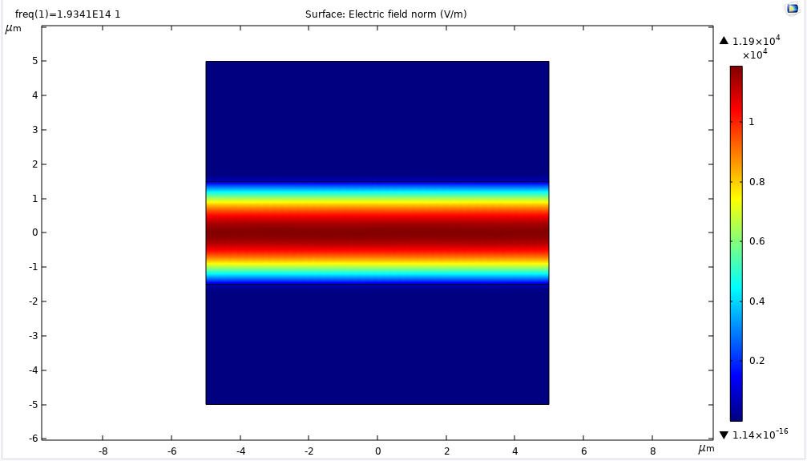

## Reflection and Transmission Calculations

𝑎bs(𝑆11) = 7.352880570194706E-4

𝑎bs(𝑆21) = 0.9999997296757004

## Comments

* The Neff calculated for all cases is that at the input port
* Neff is very close to the refractive index of the core material which is expected for a waveguide. This is explained in the normalized electric field plot as it is zero outside the waveguide. Accordingly, the electromagnetic wave is entirely enclosed in the waveguide, from the eq. $n_{eff}=\frac{cβ}{ω}=\frac{cβ}{2πf}$, Neff depends on the wave parameters.
* 𝑆11 (reflection) is very small compared to 𝑆21 (transmission) which is very high explained as an outcome of the matching between the two cores (both have the same material and dimensions) so it is the same as having no middle interface (as shown) which perfectly guide the TM fundamental mode in the core with very high transmission.

# B)

## The Fundamental TM Mode at port 1:

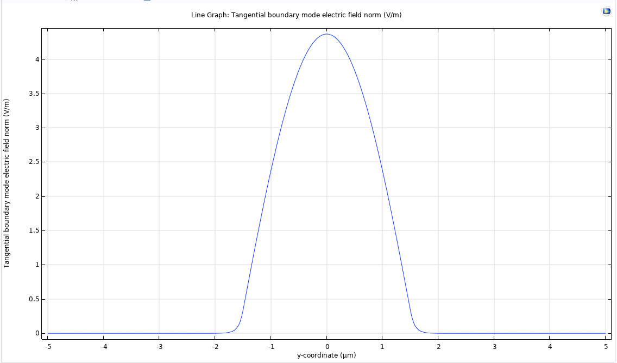

## Table calculation



## Neff

𝑛𝑒ff = 3.4913669737377515

## Normalized Electric Field Intensity

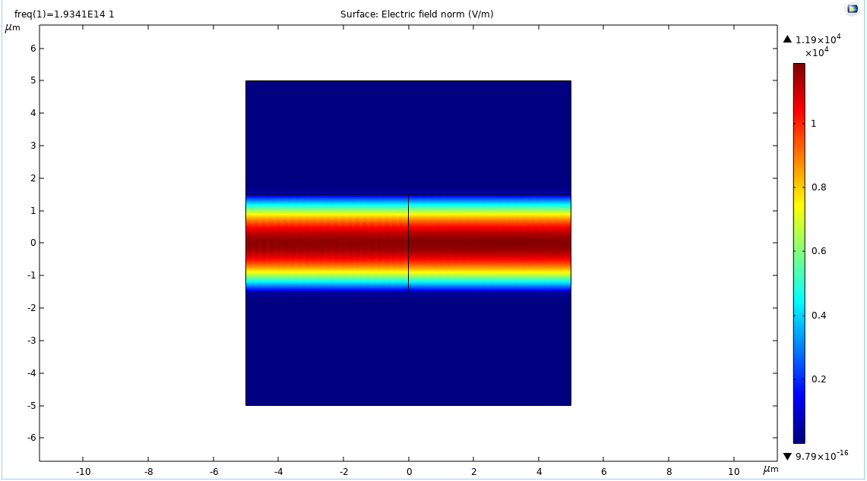

## Reflection and Transmission Calculations

𝑎bs(𝑆11) = 0.00971827686429086

𝑎bs(𝑆21) = 0.9999527764323647

## Comments

* Neff is very close to the refractive index of the first core material (left)
* Similar to case 1, 𝑆11 (reflection) is very small compared to 𝑆21 (transmission). However, it is higher than case 1 due to the slight difference between the two cores at the interface
* The high concentration of the norm E-field in the center of the waveguide shows that the waveguide achieves perfectly guided transmission of the TM fundamental mode in the cores with high efficiency
* The standing waves observed in the first core (Left) indicate the weak reflection that has taken place

# C)

## The Fundamental TM Mode at port 1:

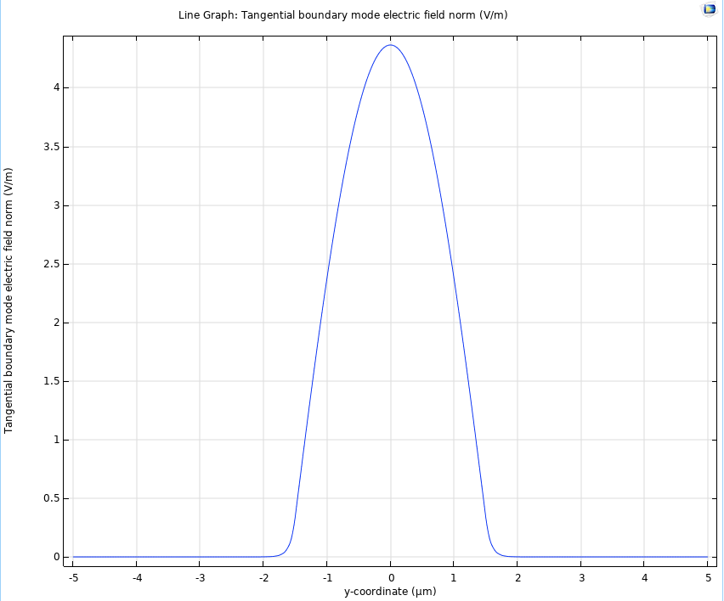

## Table calculation



## Neff

𝑛𝑒ff = 3.4312343239550276

## Normalized Electric Field Intensity

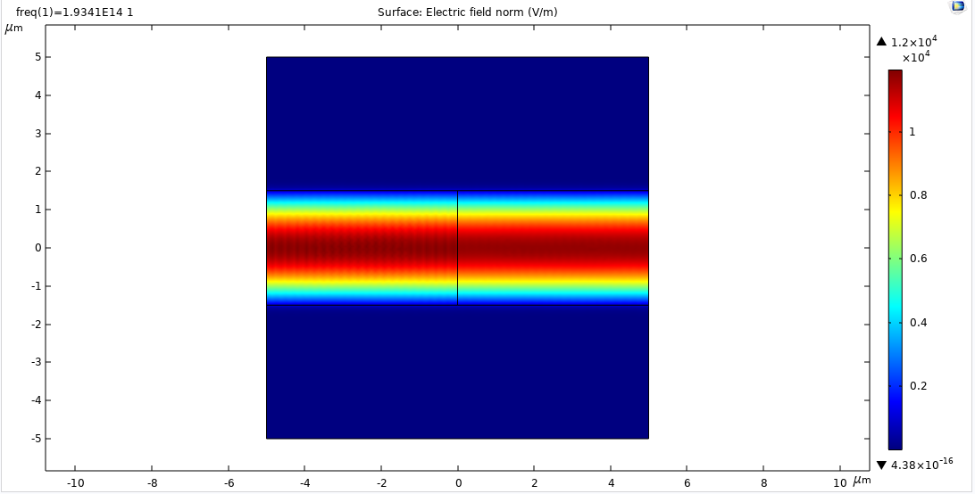

## Reflection and Transmission Calculations

𝑎bs(𝑆11) = 0.010136907187487994

𝑎bs(𝑆21) = 0.999948620236395

## Comments

* Neff is very close to the refractive index of the first core material (left)
* Similar to case 1, 𝑆11 (reflection) is very small compared to 𝑆21 (transmission). However, it is higher than case 1 due to the slight difference between the two cores at the interface
* The high concentration of the norm E-field in the center of the waveguide shows that the waveguide achieves perfectly guided transmission of the TM fundamental mode in the cores with high efficiency
* The standing waves observed in the first core (Left) indicate the weak reflection that has taken place
* There is almost no difference than results shown in case 2, except that effective mode calculation (1 & 2) are swapped in this case compared to case 2 which is expected.

# D)

## The Fundamental TM Mode at port 1:

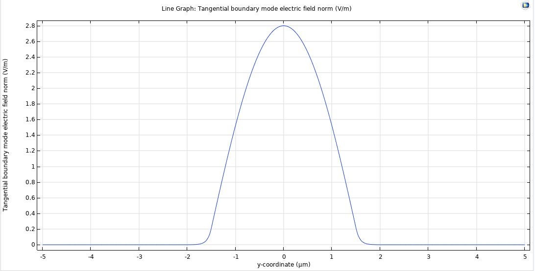

## Table calculation



## Neff

𝑛𝑒ff = 3.4913680764793864

## Normalized Electric Field Intensity

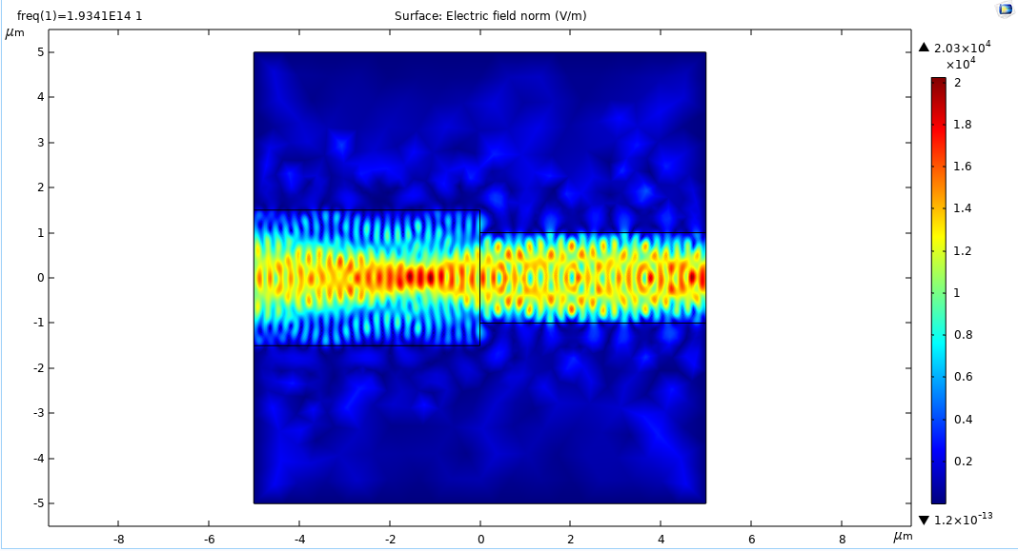

## Reflection and Transmission Calculations

𝑎bs(𝑆11) = 0.07004469984662373

𝑎bs(𝑆21) = 0.9975438536843331

## Comments

* Neff is very close to the refractive index of the first core material (left)
* Compared to other cases, some power is dissipated outside the waveguide in this case so not perfectly guided in this structure
* Since the structure is not uniform as in previous cases, the E-field norm is also not uniform
* It is worth mentioning, sum of reflection and transmission values do not sum to 1 ( 𝑆11+ 𝑆21 = 1.06758855353) which is an indicator that there is mismatch between the two cores